Team: |  | Date:
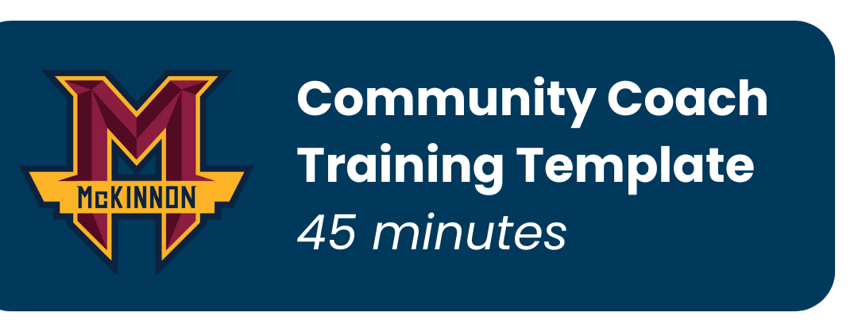

Training Theme (optional):
New Concept/Skill Being Taught:
How I want players to feel:

LIGHT TEAM | DARK TEAM

TIME | ACTIVITY | NOTES
Pre | Preparation / Greeting Players
1min | Intro The Session
6min | Activity #1 (Energiser)
6min | Activity #2
1min | Drink Break
7min | Activity #3
7min | Activity #4
1min | Drink Break
7min | Activity #5
7min | Activity #6 (if needed)
2min | Huddle Up
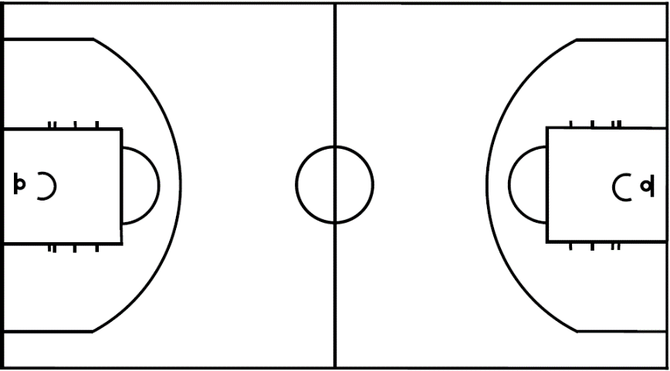

Reminders to self:

